**Problems**

**1.2.2** (code sample)

2.2.png

**1.2.6** (code sample, make sure to test this thoroughly)

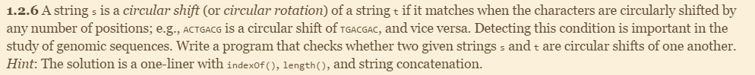

**1.2.7** (drawing an illustration of the method calls can help here)

**This would return a string will all of the characters in reverse order. If you put in “cat” it would return “tac”**

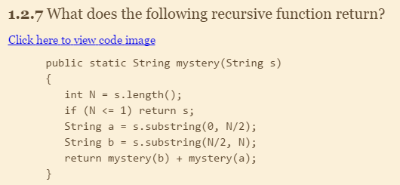

**1.2.16** (code sample, you do not need to use Euclid's algorithm to avoid common factors)



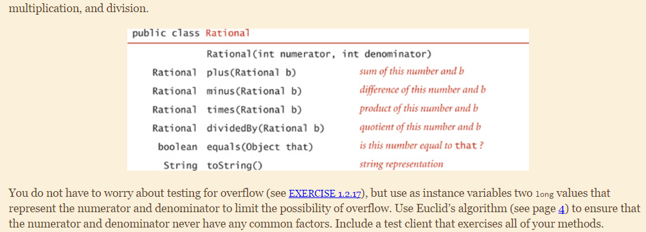

**1.2.17** (code sample, you can use the Long.MIN_VALUE and Long.MAX_VALUE constants to determine the smallest or largest long value that is representable in Java)



**1.3.3**

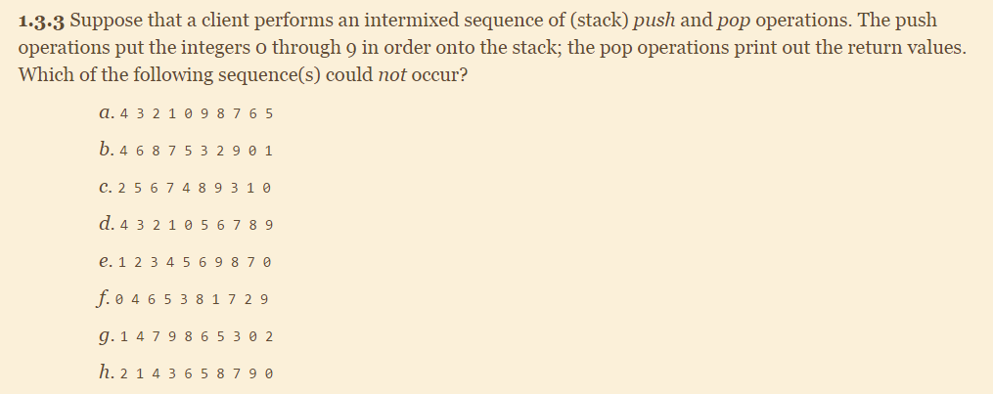

a) 0, 1, 2, 3, 4, pop 4, pop 3, pop 2, pop 1, pop 0, 5, 6, 7, 8, 9 pop 9, pop 8, pop 7, pop 6, pop 5

b) put on 0, 1, 2, 3, pop 4, 5, pop 6, 7, pop 8, pop 7, pop 5, pop 3, pop 2, pop 9, ERROR!!

c) 0, 1, 2 pop 2, 3, 4, 5 pop 5, 6 pop 6, 7 pop 7, pop 4, 8, pop 8, 9 pop 9, pop 3, pop 1, pop 0

d) 0, 1, 2, 3, 4,pop 4, pop 3, pop 2, pop 1, pop 0, pop 5, pop 6, pop 7, pop 8, pop 9

e) 0, pop 1, pop 2, pop 3, pop 4, pop 5, pop 6, pop 7, pop 8, pop 9, pop 0

**f) pop 0, 1, 2, 3, pop 4, 5, pop 6, pop 5, pop 3, 7, pop 8, Error!!!**

**g) 0, pop 1, 2, 3, pop 4, 5, 6, pop 7, 8, 9 pop 9, pop 8, pop 6, pop 5, pop 3 Error!!!**

h) 0, 1, pop 2, pop 1, 3, pop 4, pop 3, 5, pop 6, pop 5, 7, pop 8, pop 7, pop 9, pop 0

**1.3.4** (code sample, you can use Java's Stack class here)



**1.3.6**

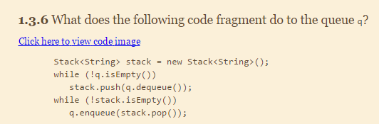

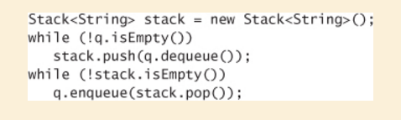

**While q is not empty, remove element from the beginning of q and add it to the top of stack.**

**While stack is not empty, remove element from top of stack stack, add to the end of q**

**1.3.13**

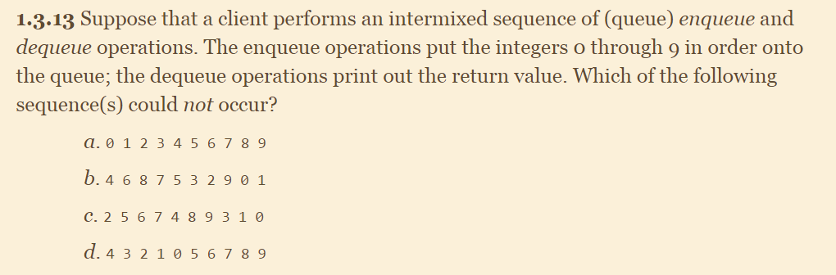

**A queue is first in first out, so if the queue is putting in integers 0 through 9 in order then a is the only acceptable output.**

**1.3.14** (code sample)



Note, your queue should display the following behavior:

* Your queue should add elements to one end of your internal array and remove elements from the other end.
* You should be able to add elements as often as you like to the Queue (ie. the internal array should resize itself when out of space).
* You should be able to remove elements until the Queue is empty.

**1.3.27** (code sample, this will require you to write a linked list Node class)

